Overseas Fieldwork to
Kaosiun & Taipei

for APE students (APE I, II, III, IV and V)

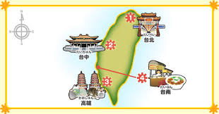

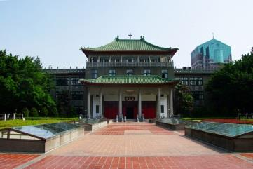
- Date: 2/26(Sun)-3/3(Fri)
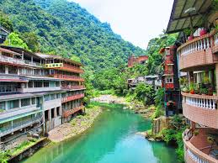
- The educational highlights
  - English usage in real-life situations
(English as a lingua-franca)
  - Experience Taiwan’s real cities and natural areas
  - University tour/meet local students
(Wenzao Ursuline University of Language)
  - Join the university’s English class and Japanese language class with the local students
  - Study Taiwan’s culture and history
- Price: ￥45,000*
This price will include the following:
  - Roundtrip plane ticket
  - Hotel stay (two to four people per room)
  - The main transportation during the trip & Entrance fees for the activities
*The price may change depending on how many students wish to join us.
*This price is very reasonable because students will receive a grant from YCU.
*Additionally students will need money for personal shopping and meals.
- Application Deadline: Dec 7 (Wed)
If you want to join the trip, fill out the form at the PEC and submit it during the date below.
- Application Period: Nov 9 (Wed)-Dec 7(Wed)/PEC opens 9:00-13:10, 14:10-17:00 (Mon-Fri)
- Payment Deadline: Dec 9(Fri)/Must arrive in the PEC bank account
- If you have any questions, please come and ask Yoko Igarashi (RM 212/ yokoiga1@yokohama-cu.ac.jp) or Paul Nehls (RM239/nehls@yokohama-cu.ac.jp)
- Max: 15 students* (PE Teacher, Mr. Paul Nehls will go with the group)
*First come, first serve. So Hurry!

Note: If you do not have a passport, we urge you to apply for one ASAP. We also advise you to prepare a credit card if you do not have one. We will send important notice via YCU e-mail. Please check it frequently.

