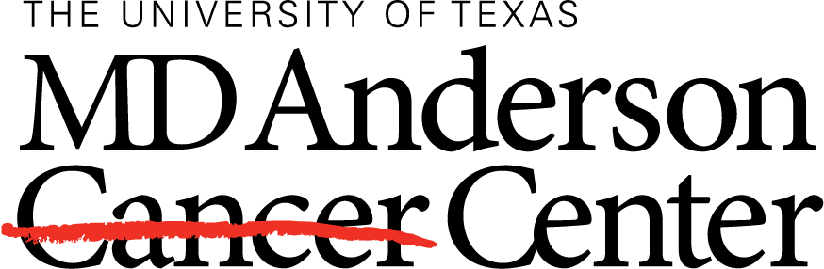
Global Academic Programs
INFORMATION INTAKE FOR REQUESTING OBSERVERSHIP: Currently no space available in Breast, Thoracic, GI medical oncology for 2017. No space available in Breast for 2018.
NAME:
Male/Female:
DATE of BIRTH (M/D/Year):
EDUCATION:
TIME FRAME
(Preferred Date M/D/Year) :
INTEREST AREA: | Surgical or Medical? _________________  - __________________  - __________________  - __________________
GOALS/EXPECTATIONS:
INSTITUTION NAME:
COUNTRY:
HOSPITAL:
ADDRESS:
EMAIL ADDRESS:
CONTACT NUMBER:
Attached CV (Yes or No)

